# Selecting the right Plastic Mold Maker for OEM Manufacturing

# Introduction

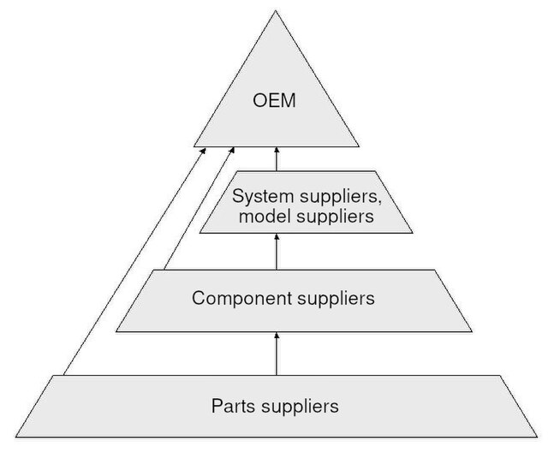OEM (Original Equipment Manufacturer) manufacturing is a dynamic and complex process in which OEM manufactures components that are assembled and branded by other companies to produce their end products. OEM manufacturing plays an important role ranging from automotive to medical devices to consumer goods. A major area of use of this process is in the creation of molds, especially plastic molds. The fundamental step for ensuring the success of your OEM project is choosing the right plastic mold maker. The choice of a mold maker exerts a profound impact on the quality, efficiency as well as success of an OEM project. In this article, we will delve into the importance of mold makers in manufacturing and discuss key considerations like expertise, quality standards, possibility of long-term relationships in the evaluation and selection of potential mold makers as per your needs.



# Contents of the article





* Understand aspects like sustainability, after-sales support, and risk management and choose the right mold maker.
* The importance of ensuring successful long-term partnerships and quality-focused collaborations.
* Other criteria like innovation, reliability, cost efficiency, etc. to make judgments about the mold makers to select the best mold maker.

# Importance of selecting the right plastic mold maker in OEM manufacturing

1. **Quality and Precision:** If you know a highly regarded mold maker, you can be sure that he/she maintains the quality of the product by taking care of the precision, accuracy, and also the durability of the molds.
2. **Cost-Efficiency and Optimization:** Mold specialists have the ability to optimize the process of design and manufacturing which results in a reduction of material waste as well as overall manufacturing and production costs.
3. **Customization and Flexibility:** Only proficient and experienced mold makers hold the ability to make customizations and flexibilities to the products as per the customer's demand.
4. **Reliability:** An adept mold maker usually sticks to schedules and places a major focus on timely deliveries in order to be more reliable than others.
5. **Innovation and Problem-Solving:** Skilled mold makers offer innovative solutions and problem-solving skills. Their ability to troubleshoot issues, provide design recommendations, and adapt to changes improves the productivity during the manufacturing process.
6. **Long-Term Partnership:** Last but not the least, the most crucial factor in business is to maintain long-term partnerships and choosing the right mold maker can be a long-term relationship builder useful results in future projects.

**Role and significance of mold makers in creating customized products**

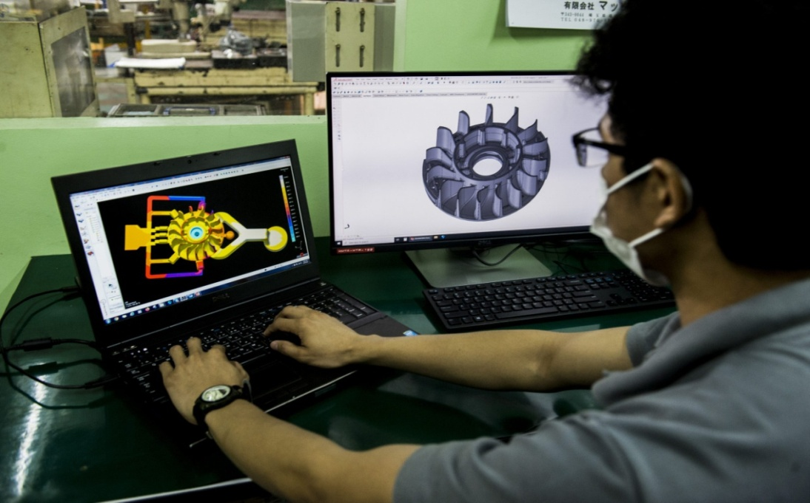

Source: <https://makoto.com.ph/tech-and-dev/die-mold-making/>

1. Mold makers should be deemed as materials experts in order to make the best material selection that is able to fulfill the design requirement at the minimum possible cost.
2. Mold makers need to be skilled enough so that the customers can trust them to carry out complex design execution.
3. They need to have the knowledge of how to scale production as well as manage the production volume efficiently to ensure the seamless production of customized components.
4. No doubt that mold makers should be pro in making CAD models for prototyping, testing and modifications before full-scale production to exhibit consistent standards.
5. Overall, they should be abreast of the latest technologies to meet the evolving needs of customers.

# Overview of essential considerations that need to be defined before approaching mold makers

1. **Defining Project Scope and Requirements:** The first and the foremost step is tostate the desired outcomes, technical details, and precision and quality standards for manufacturing items that creates a clear roadmap leading to a mutual understanding between the OEM and the manufacturing partner.
2. **Design Specifications:** You need to provide clear and unambiguous design specifications like dimensions, intricate features, and surface finish and so on.
3. **Quantity and Production Volume:** You have to determine the quantity and production volume so that you can help the mold maker optimize the manufacturing process for efficiency.
4. **Budget ration:** Obviously, this is the most important consideration to be defined so that the mold maker can suggest appropriate materials and design techniques.
5. **Timeline and Delivery Schedule:** Let the mold maker know the timeline like delivery deadlines so that he/she plan and schedule production accordingly.

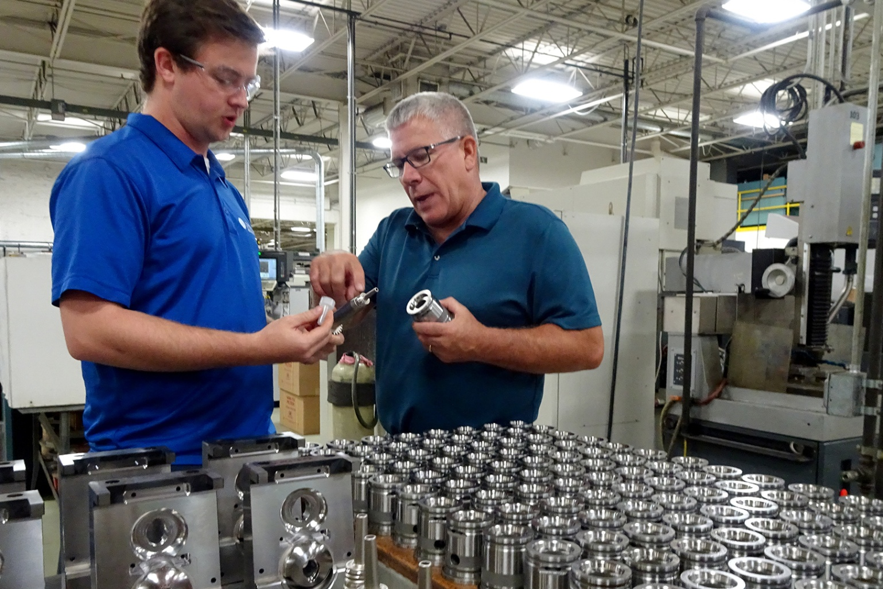

Source: <https://www.moldmakingtechnology.com/articles/the-greatest-moldmaker-in-the-world>

# Importance of clear and concise project specifications in finding the right mold maker

* Ensure accurate quotes
* Lead to precise design alignment
* Result in efficient communication
* Allow strict adherence to timelines
* Result in a successful or maybe long-term collaboration or partnership by extenuating risks.
* Mold makers with broad experience are able to navigate complexities, anticipate challenges, and deliver solutions better than those with less experience.

**Strategies for researching and identifying potential mold makers suited for OEM manufacturing**



1. You can explore trade shows and online directories dedicated to mold manufacturing and obtain the information you need from these.
2. Nowadays, comprehensive online research can answer anything you ask. Likewise, conducting in-depth online research reading reviews and case studies can help you identify the best option.
3. You can request for quotes (RFQs) from the manufacturers regarding the information about capacity, pricing as well as uptime.
4. You can also make some factory visits for to obtain live information about their operations, equipments and their quality control methods.
5. Reviewing the portfolio and past projects helps in evaluating their skills and experience.
6. Assessment of the mold maker's history and experience in handling highly customized projects to ensure their ability to craft molds aligning with the OEM specifications.

**Significance of shortlisting mold makers based on their expertise, experience, and capabilities**

1. Ensures their possession of required technical skills and precision.
2. Helps in selecting mold makers who carry innovative approaches and flexibility.
3. If they have successful track records until now, it shows that they are able to guarantee a smooth effective production process with high-quality products.
4. Knowledge-based selection ensures conformance to quality standards as defined by manufacturing standards of industries.
5. If you select mold makers who prioritize a collaborative approach, it may result in fruitful long-term partnerships.

**Evaluating Technical Competence and Experience**

# Criteria to assess the technical skills, knowledge, and experience of mold makers:

1. Material skills: Assess their expertise in selecting and operating materials, considering their properties as well as suitability for specific industry needs.
2. Technical skills and manufacturing tools: You need to check the mold maker’s proficiency in advanced design software and modern technology.
3. Industry-Specific Experience: Also investigate the history of mold manufacturers' experience in areas similar to required OEM operations to ensure they understand such requirements.
4. Quality control and standards compliance: Assess the mold manufacturer’s approach to quality control, compliance with certifications, and stringent adherence to industry standards.
5. Demonstrated Success in OEM Projects: You need to read the reviews, customer references, or case studies showing successful completion of OEM projects.

# Importance of a mold maker’s capability to meet unique and specific project requirements

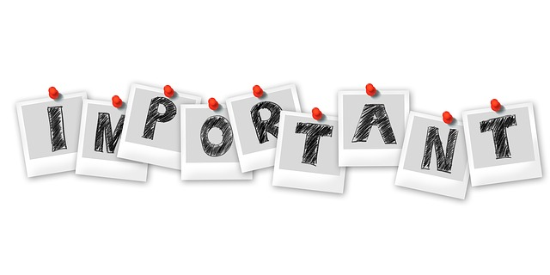

1. Helps to meet as well as maintain design, accuracy and performance standards.
2. If they are capable of doing this, they can deliver molds that can seamlessly combine into the final product, ensuring consistency with the OEM’s brand identity and quality standards.
3. It helps in establishing a productive and harmonious partnership.

**Quality Assurance and Standards Compliance**

# Evaluation of a mold maker’s quality control procedures and adherence to industry standards

1. In the OEM industry, it is indispensable to develop a research program to ensure the production of high-quality products that meet industry specifications.
2. Helps to maintain accuracy, consistency and reliability throughout the manufacturing process.
3. If they are evaluated time and again, it builds their commitment to quality and reliability, fostering trust and confidence in consistently meeting stringent OEM standards.
4. Helps build confidence in the manufacturer’s ability to produce products that consistently meet strict OEM standards.

# Importance of flexibility, innovation, and adaptability in OEM manufacturing

1. Innovation is needed to stay abreast of technological developments, latest tools and techniques.
2. To stay as the top mold makers in the market, they need to be flexible and also adaptable in any kind of environment to meet any unique demands that appear in the manufacturer's way.
3. Adaptability and flexibility clearly increases operational efficiency and quality of the mold makers and their products.
4. By carrying enough knowledge on innovation and change, manufacturers can prepare for future changes and stay at the forefront of the market.

**Reviewing Previous Projects and Client Feedback**

# Analysis of a mold maker’s past projects and client

# It is evident that analysis of past projects provides real insight into the projects and this process helps in deciding if they are the most suitable mold makers and also proves that these mold manufacturers are adept at achieving complex as well as intricate design requirements and also meet the OEM standards.





# Role of client feedback and reviews

1. Customer certification provides a real perspective on the mold manufacturer’s performance and reliability.
2. Sheds light on the quality of service and experience enjoyed by customers.
3. Assessment of the way the mold manufacturer handled challenges in past projects reveals their flexibility and problem-solving skills.
4. Demonstrates whether the mold manufacturers are able to complete the manufacturing of tailored-made products or not.
5. Helps in judgment about the reliability of the mold manufacturer to consistently deliver high-quality molds to projects.
6. Reviews help in determining the record of accuracy and quality they maintain during their project.
7. Helps in making an informed decision whether to have a long-term relationship with them or not.

**Pricing, Quotation, and Contract Negotiation**

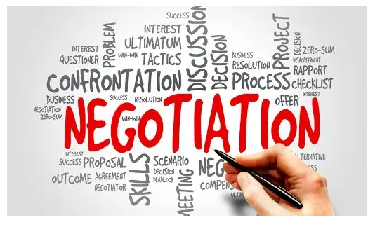

Source: <https://www.redsheeptrading.com/price-negotiation-service-with-suppliers>

# Scrutiny of pricing structures, quotations, and the value proposition offered by the mold maker

A thorough inspection of pricing structures, quotes, and pricing assumptions evidently plays an important role in understanding the overall cost and helps in assessing the value of a mold manufacturer’s proposed partnership in the OEM industry. If the price sits well with you i.e., you think that the pricing is budget-friendly and you think that the partnership adds sufficient value to your project, you can start the partnership with the manufacturer. Clear, concise and comprehensive quotes are essential that depict clarity about the services or products offered and associated costs. The evaluation of the value proposal makes judgments about the quality of service, materials used, production capacity, and any added benefits to ensure that the price is commensurate with the knowledge and quality. Hence, this comprehensive analysis helps in making informed decisions about how to carry out the manufacturing process.

# Discover how to negotiate the best price for a business | Daltons BusinessImportance of transparent and fair contract negotiations in establishing a successful partnership

Source: <https://www.daltonsbusiness.com/advice/seller-guide/negotiate>

1. **Clear Framework Establishment:** Transparent and fair negotiations produce a complete framework defining phrases, responsibilities, and expectations.
2. **Clarity on Project Details:** Negotiations offer lucid information on scope, timelines, fees, and deliverables.
3. **Fostering Trust and Confidence:** Fair negotiations obviously build trust, understanding and consistency between both parties and launch a harmonious partnership.
4. **Legal Safeguarding:** Of course, the main importance of this procedure is that it offers legal protection to assist and emphasize both the rights and duties.
5. **Long-Term Relationship Foundation**: It is a well known fact that transparent negotiations pave paths for a productive, long-term and fruitful relationship that benefits both parties in the future.
6. **Mitigation of Misunderstandings:** As already mentioned, transparent and fair negotiations result in effective communication that decreases the chance of misunderstandings. Establishing clear and unambiguous phrases in the settlement mitigates potential conflicts and results in the improvement of verbal exchange and collaboration during the partnership.
7. **Risk Reduction:** Transparent contracts assist in mitigating dangers and uncertainties with the aid of truly outlining responsibilities, in the end decreasing ability disputes or ambiguities.

# Conclusion

Choosing the right plastic mold maker in the OEM industry isn't just a choice but it is a crucial decision that guides the success of the project. In order to make a perfect choice, you need to examine critical factors ranging from their technical expertise to their ability to meet the customized demands of the customers. The importance of transparent communications, honest contracts, and emphasis on assessment of past transactions and customer feedback serve the mold makers to not only address specific issues but also promote innovation, reliability, and long-term business success. Choosing the right mold maker to match your unique business needs is a fundamental step that leads to optimized excellence in the competitive area of OEM manufacturing.